# Kanban – Support

The prebuilt *Kanban – Support* provides an overview of registered support cases in your NetSuite account, with each Kanban column representing a case status in the support flow.

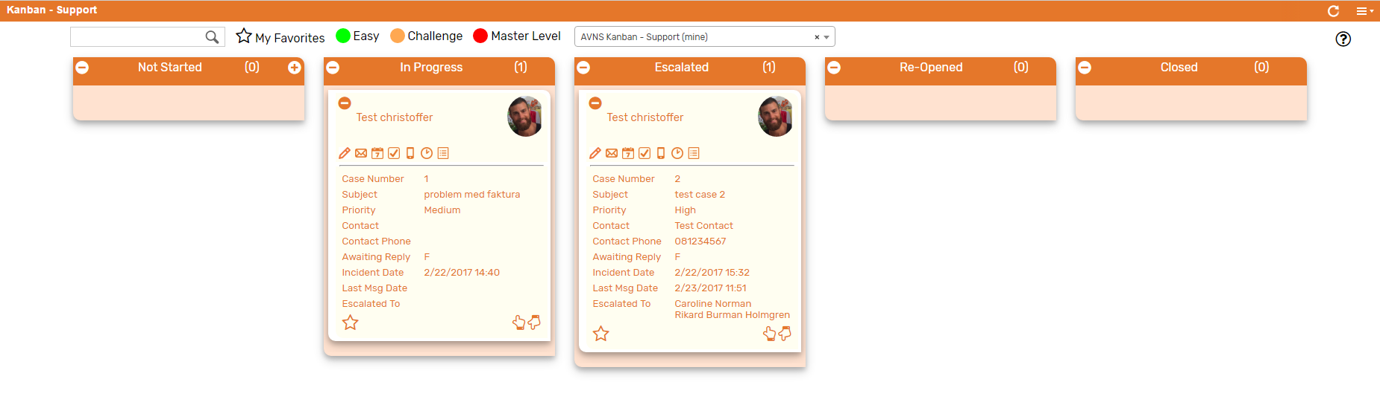

### Kanban – Support: Prerequisites

Before using the *Kanban – Support*, please make sure the prerequisites listed below are fulfilled in order for the board to function as expected.

1. **Support Rep & Sales Rep Image**  
   Make sure to mark the checkbox ‘Support Rep’ on the Employee record for all available Support Reps.   
   If an image has been uploaded to the *Image* field on the Employee record, this image will be displayed on the Kanban card. If no image is available, a predefined profile icon will be displayed instead.

### 

### Kanban – Support: Card Moves & Column Actions

The *Kanban – Support* board contains five Kanban Columns. Each column has been configured with one or several Column Actions. Double clicking on any card in the *Kanban – Support* board will open the case record in edit mode.

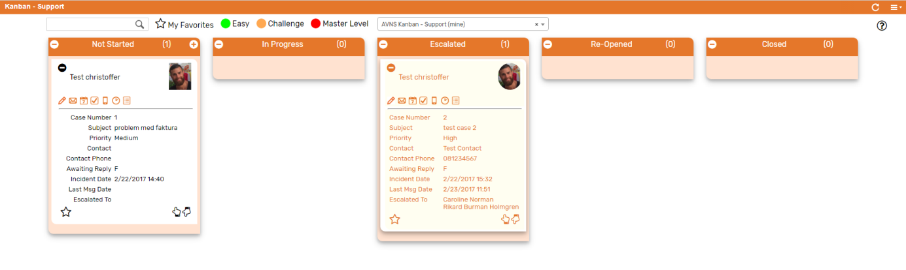

1. **Not Started**
   1. *Card Moves* – Kanban cards in the column *Not Started* can be moved to all other columns in the Kanban board except Re-Opened.
   2. *Column Actions* – when moving a Kanban card to the column *Not Started* the status of the record represented in the Kanban card will be updated to *Not Started*.
2. **In Progress**
   1. *Card Moves* – Kanban cards in the column *In Progress* can be moved to all other columns in the Kanban board except Re-Opened.
   2. *Column Actions* – when moving a Kanban card to the column *In Progress* the status of the record represented in the Kanban card will be updated to *In Progress and the* Assigned To *will be updated to @MySELF@* (Current User).
   3. *Add Card* –It is possible to add a Kanban card (a new record) from the column *Not Started* by clicking on the + icon in the top right corner of the column.
3. **Escalated**
   1. *Card Moves* – Kanban cards in the column *Escalated* can be moved to all other columns in the Kanban board except Re-Opened.
   2. *Column Actions* – when moving a Kanban card to the column *Escalated* the status of the record represented in the Kanban card will be updated to *Escalated*.

1. **Re-Opened**
   1. *Card Moves* – Kanban cards in the column *Re-Opened* can be moved to all other columns in the Kanban board.
   2. *Column Actions* – when moving a Kanban card to the column *Re-Opened* the status of the record represented in the Kanban card will be updated to *Re-Opened*.
2. **Closed**
   1. *Card Moves* – Kanban cards in the column *Closed* can be moved to all other columns in the Kanban board.
   2. *Column Actions* – when moving a Kanban card to the column *Closed* the status of the record represented in the Kanban card will be updated to *Closed*.

### Kanban – Support: Available Card Actions

The Kanban cards in the *Kanban – Support* board each contains seven Card Actions.

1. 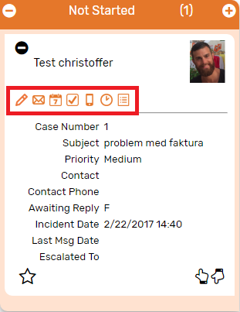**Support: New Note**Add a new note to the case from the Kanban card.
2. **Support: Send Email**

Create an email message and send directly from the Kanban card.

1. **Support: New Event**Add a new event to the case from the Kanban card.
2. **Support: New Task**Add a new event to the case from the Kanban card.
3. **Support: New Phone Call**Add a new phone call to the case from the Kanban card.
4. **Support: Enter Time**Add a time tracking record to the case from the Kanban card.
5. **Support: View History**Show historical messages for the case from the Kanban card

### Kanban – Support: Alternative Searches

There are two alternative searches for the *Kanban – Support* board.  
  
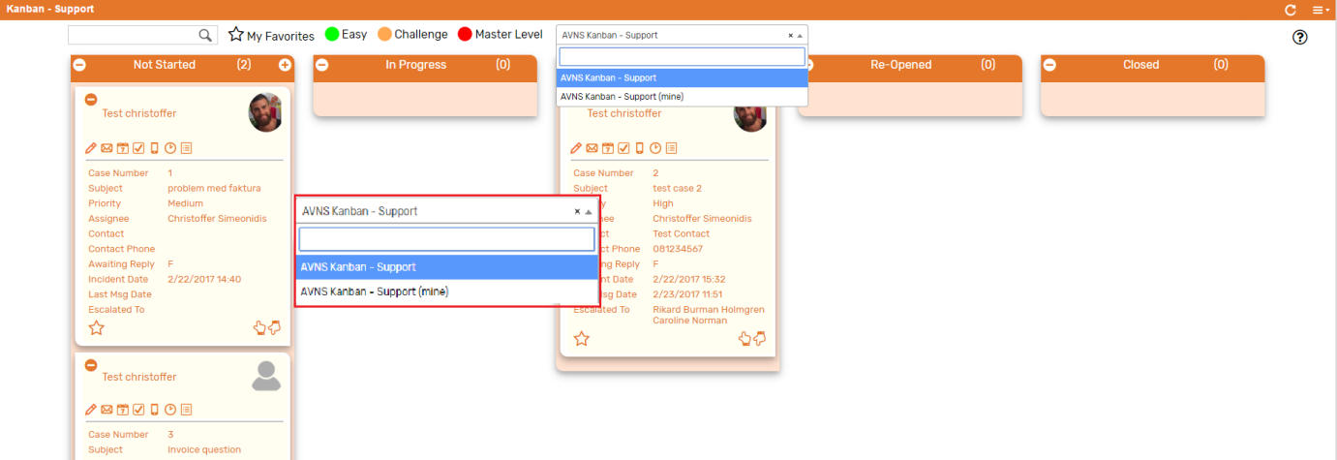

1. **AVNS Kanban – Support**This search will display all registered cases in the *Kanban – Support* board.
2. **AVNS Kanban – Support (mine)**This search will display registered cases where assigned to is *Mine* (current user) in the *Kanban – Support* board.

### Kanban – Support: Available Colors

There are three colors available for the *Kanban – Support*, which can be used to highlight and filter the Kanban cards (*Easy // Challenge // Master Level*). These are defined in the *Color* subtab of the Kanban configuration record.

